Village of New Maryland
Spring Leaf Pick-up 2021

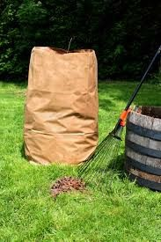
FERO will be picking up paper bags of leaves on:
The EAST side of Hwy. 101 - Wed. May 26th
The WEST side of Hwy. 101 - Thur. May27th
- Bags of leaves will NOT be picked up prior
to these dates.

Please have your bags to the curb by bags to the curb by
7:00 am the morning
of pick-up.
QUESTIONS?

Call the Village office at 451-8508 or
Email: office@vonm.ca

Important Points to Remember:

NEW this year: For the SPRING leaf Please have your bags to the curb by bags to the curb by
7:00 am the morning
of pick-up.
- collection residents can use either compostable paper bags or plastic bags in which to collect their leaves. (Please note for the FALL Leaf Pick-Up in November 2017 residents will be required to use ONLY compostable paper bags.)
- ONLY bagged leaves will be accepted.
- NO branches, NO garbage, NO twigs, NO animal waste, NO yard debris, NO grass clippings will be accepted.
- Any bags of leaves that are found to contain items other than leaves will be left at the curb for residents to clean up and dispose of themselves.

